|  |
| --- |
|  |
| Data Science for social impact Final Project |
| Analysis of Investing in Cash Transfers to Raise Long-Term Living  Frank Jiang, Claudia Solis-Roman, Drew Chung, Silvia Jin |

|  |
| --- |
| Fall 2019 |

Introduction

To reduce poverty is always one of the hot spots of society in developing countries. Conditional cash transfer (CCT) programs have been used in many countries to solve the problem of poverty. The Oportunidades Program is a CCT program established by the Mexican government in 1997 which provides 90 pesos to eligible families on a bimonthly basis under conditions of supporting child education. The objective of this program is to break the intergenerational transmission of poverty by providing financial support to qualified families and encourage them to invest in the human capital of children. Policymakers and development practitioners have been concerned about whether the families become dependent on this program and would they be able to maintain their living standards when transitioned off this program. Therefore, we decided to investigate the long term effect of the Oportunidades Program in raising participants’ living standards by measuring their home assets and the agricultural and nonagricultural investment they made starting from they enrolled in this program to the end of the program. This is our fundamental motivation for this study. Moreover, as we explored more related studies, we noticed that this study is the first to consider the long-term effect of the CCTs via the investment pathway. To our knowledge, there was a study estimated the effect of payments from the Mexican agricultural assistance program on consumption (Janvry & Davis,2001). Wooduff and Zeneno(2007) and Yang(2008) also showed that people use private remittances as capital to invest in microenterprises. But there is no study tried to explore the effect of CCTs in the long run via the investment pathway. This is a strong motivation for us to start this longitudinal study.

Stakeholders

There are plenty of important stakeholders for this research. The main stakeholder has to be the Oportunidades program itself. The leaders of the program would love to learn more about their program and how effective it is at raising long term living standards. If the numbers are positive, they can request financial support and gain political support. If the program is producing negative effects, they can sort out the problems and change parts of the program to create positive effects. The Mexican Government, the Vicente Fox administration, in particular, is a major stakeholder. During his time in office, President Fox was a main advocate for the program. The positive effects of this program would garner more votes for Vicente Fox and create a greater public image for himself.

Those two groups would be the main stakeholders because they are the two groups that can change the program with their power. These next few stakeholders are stakeholders that are very invested in the research but don’t have the power to make that change. Current families enrolled and eligible families looking to enroll in the future are two huge stakeholders. Families currently enrolled would love to know whether or not the program that they are in is truly effective or not. If it is not creating a positive effect, they can withdraw from the program. And of course, the families looking to enroll in the future can look at this research to help them decide on whether they should enroll in the program or not.

Other stakeholders that are not as invested in the research but still have incentives are The Mexican Agricultural Department, the Department of Education, Mexico’s Healthcare System, and other poverty-stricken countries. The 3 departments of Mexico that we mentioned all have incentives to know whether or not the Oportunidades program positively affects Mexico. The main idea of the cash transfer is for families to invest their money from the program into agriculture and create agricultural products. The Agricultural Department would be interested to see the program’s effectiveness on the country’s agriculture as a whole. There is a long-term health analysis in the research as well. The Healthcare system would love to see results that show the Oportunidades Program correlates with fewer sick days. The Oportunidades program also pays more to families whose children attend school often and receive passing marks on exams. The Department of Education would love to see more students come to school and achieve high scores. And finally, any other country that has poverty issues of their own would be interested in seeing the possible benefits of a cash transfer program such as the Oportunidades program and consider the possibility of starting a similar program in their own country.

For any research project, the researchers themselves are always stakeholders. Their incentives are satisfying their curiosity, gaining knowledge in public service or their respective fields, impacting our society, and of course, publishing their work and gaining recognition. So our three researchers: Paul J. Gertler, Sebastian W. Martinez, and Marta Rubio-Codina, are also stakeholders for this researcher project.

Description of Data and Political Challenges

Data for this study came primarily from surveys. Data were from the controlled randomized experiment of the Oportunidades CCT program in Mexico and the Mexican census. Oportunidades household and community questionnaires were administered as part of the RCT. This was a socioeconomic survey of all households, the Encuesta de Características Socioeconómicas de Los Hogares (ENCASEH), that the Government used to determine eligibility in conjunction with data from the census (Conteo de Población y Vivienda). This survey data included information about both beneficiary and non-beneficiary households, including assets (including whether homes had electricity, whether homes had a dirt floor, and whether families were homeowners). This data at baseline also included ownership of productive farm assets, like farm animals and land for agriculture, and features of health status and tracked these along with consumption and spending both during the 18-month time span families receive cash transfers, as well as 4 years later. This data collection was largely in line with related CCT program literature, with the addition of information reported about the investment pathway, namely what share of income was spent on productive farming products.

To test the hypothesis that a secure stream of income from a conditional cash transfer program would lead poor households to make more investments in productive assets and that activities via such investments, and subsequently lead to improvements in long-term living standards that persist even in the absence of the cash transfer program, these surveys of household characteristics and spending outcome data sources were combined.

Access to Data

A research partnership arose between the researchers, which themselves are a collaboration between an economist at Berkeley, a Researcher at the IADB arm of the World Bank, and a Researcher at the Institute for Fiscal Studies, and Oportunidades, the implementing program itself, in Mexico.

The research design and structure of the data relied on the randomization and phased in roll out of the programs across communities in Mexico.

The data used are from the program’s rural evaluation surveys, the Encuesta de Evaluación de los Hogares Rurales (ENCEL) as well as data from the 1997 ENCASEH census for baseline (pre-intervention) information and administrative records on transfer of payments to households in the evaluation sample. The ENCASEH contains the basic socioeconomic household information that was used to classify households in selected communities as eligible or ineligible for treatment.

It requires access to the previously collected data from the ENCEL Data in 1998 on ‘income from selling animal derivative products’ for studying the causal relationship.

Follow up survey is needed in 2003 to investigate if there is a raise in their long-term living standard.

A research partnership with the local agencies or research organization is needed for access to the socioeconomic status of the locals and the selection of appropriate participants.

Both getting access to and then linking the ENCEl to the ENCASEH datasets (which would have required individual level characteristics, which presents confidentiality issues) probably involved special relationships or application processes with the Mexican government.

Perhaps having researchers on the authors list that are connected to institutions that provide funding to Latin American countries facilitated collaboration.

IRB approval is likely not necessary, since this meets the research on human subjects using identifiable information requirement but does not entail using data about individuals that is private or that has been provided with a reasonable expectation that it will not be made public. The data used are from the national census, and a survey that was purposely conducted to collect data for research and operational purposes concerning Progresa/Oportunidades.

Data and Policy Fit

We might be interested in the health and education gains for the next generation, and 18 months of data collection, although it does extend beyond the end of the conditional cash transfer program, it does not tell us much about the long term cross generational gains to such a program. The authors discuss the breaking of intergenerational transmission of poverty as the motivation of their study, and certainly it is part of the theory of change of the CCT program which specifies conditions for cash transfers that encourage educating children in rural areas that might have competing motivations to have children work on farms. Nonetheless, child outcomes in mid or early adulthood are not captured by this study and the duration of the data available.

Although there is a good amount of data for our long-term effects and effect on investments for agriculture and microenterprises, the main measure of poverty and living standards would be family income. It would be beneficial to our research question if we had the income level of the families for each wave, that way we can see the increase/decrease of overall income, which can be correlated to living standards.

Since the goal of the research is to see whether the beneficiaries invest part of their cash transfers in productive enterprises to improve their long-term living, the measurement of long-term living standard reflects this goal by using follow-up surveys to test whether there are differences in consumption level between the original treatment group and original control group.

However, there exist threats to the conclusion of causal interpretations because of the ‘existence of the difference of other time-varying changes in the treatment vs control group.’ In other words, the possibility of differential unobserved time-varying factors is not considered/calculated.

Since a causal conclusion cannot be drawn from the research, it might be easily misused by making a more general statement. The result from this research is under a lot of different assumptions and conditions and might not be true for another country or even for a different program even it is similar.

Bloggers could have risks to misuse the results by phrasing the conclusions of this study in a less rigorous way, which could lead to a misunderstanding of the effect of the Oportunidades Cash Transfer Program. For example, when some bloggers want to make an attractive title, they tend to exaggerate the effect of the program. They could say: “Conditional cash transfers can help the poor become rich” or “ Join the conditional cash transfer program, be an investor with no risk”. For people who only glance at the headline but pay little attention to the study, it may give them the impression that the goal of the Oportunidades program is not helping with poor families but providing opportunities to make money.

For future participants of Oportunidades program or similar program, the misuse could happen if they are allured by the financial incentives. By believing the result of this study that poor families can raise their living standards in the long run, if the future participants decide to enroll in this program and rely on the cash transfers as a way to make a living, it will be a problem. Since the objective of the program is to support poor families to break their intergenerational transmission of poverty by investing the cash transfers in the human capital of their children, it should not be the primary income of the participating families. It does not guarantee the improvement of their living standards. Thus, it is a misuse of the participants who want to effortlessly make earnings.

Replication of Analyses

 We located the paper, accompanying documentation, read through the readme and the ten stata programs. We adjusted these as needed to run on our machines, debugged, reran, repeat, found results, matched to tables in the paper, and reshaped into meaningful tables.

We hit roadblocks well known in the reproducibility arena - outdated code commands, imperfect documentation, and various unspecified output formats. Stata commands that were outdated, namely postestimation command coefastr, used a syntax that would not run, so we adjusted these regression output code blocks. While this paper had documentation and accompanying code, the documentation included a crosswalk of programs to results that were not perfectly aligned to the final output table results and did not provide guidance to the range output formats. We solved these issues largely through trial and error, by matching numbers and statistical modeling methods used in the code to items in tables. The most garbled output format appeared to be another kind of code that resembled latex- by saving this text object as an rtf the results opened into beautifully formatted regression coefficient tables. Additionally, we wrote a new code to combine and export output into a unified combined format, an excel spreadsheet we subsequently arranged into formatted tables.

 We can reproduce the analyses in the paper and the appendix. Table 5 contains the main results describing long term consumption for families four years later. We were able to match it and get the same significance levels and standard errors. They find that household per capita consumption in 2003 is 10.84 pesos higher for (original treatment households compared to original control households, and this difference is statistically significant (the first coefficient in the first column) so about 5.6 percent higher consumption than households would have had had they not received the CCT (if we buy the causal inference design, which I do). That result suggests that returns on investments made by treatment households in the initial 18-month experimental period did translate into modest but significant improvements in long-term living standards.

 We were able to replicate the results via the code and data set that was given to us. After a long, strenuous battle of matching our results to the results of the tables in the paper and appendix, we noticed that some parts were not included in the paper. In the paper, they mainly used t-statistics numbers to discuss their findings. There were some rows of results that resulted from our code that displayed p-values; however, for the most part, p-values were not involved in the final product of the paper. This could have been the researchers’ preference or it could be possible the publisher of the paper requested only t-stats be included in the results. However, the t-stats numbers and the p-values did not show alarming different results, so this is not a huge issue for the paper. Other than this, the code represented every analysis that was run well.

New Analysis

After collecting the reproduced results from the original data, some new analysis using the coefficient of impact focusing on a different aspect of the program has been done to further analyze the impact of the program and its limitation.

Agricultural Assets

Graph 1 Graph 2

Graph 1 above shows the coefficient of impact on agricultural assets on the unconditional sample with two waves of data. The blue bar represents the impact on agricultural assets using the data from 1998-1999, while the orange bar represents the impact using the data from 2003. A conclusion can be drawn that this cash-transfer program has a positive impact on Draft animal ownership, production animal ownership, land use. In 1998-1999, this program still has a positive impact on the number of hectares use. However, the impact turns out to be a negative one on the number of hectares used in 2003. This might due to the transition in the development of the agricultural industry in Mexico. Graph 2 shows the coefficient of impact on agricultural assets on a conditional sample with two waves of data. The results are similar. Therefore, this cash-transfer program has a positive impact on participant’s agricultural assets.

Microenterprise Activity

Graph 3

Graph 3 shows the coefficient of impact on microenterprise activity. Microenterprise and handcrafts have a coefficient of 0.033 and 0.028, while carpentry and construction own a coefficient of -0.002. This result reveals the fact that participants of this program are more likely to be successful in microenterprise and handcrafts which need initial capital rather than carpentry and construction which heavily depends on physical activity. The underlying reason might be the head of participants' households are mostly women. Therefore, their advantages are most likely not work that involves heavy physical activity.

Impact of Age Group in the household

Graph 4

Graph 4 shows the coefficient of impact on different age groups exists in the household. If there exists a toddler (0-7 years old), a teenager (8-17 years old), an adult (18-54years old), an elderly adult(55 years or above), the impact of the program tends to be different. The graph summarizes that different age group has a little or no impact on home production since most of the coefficient for each group is close to 0. For consumption level, which is the measurement the program adapts for living standards, the only positive impact coefficient is when there are teenagers in the household. It reaches a coefficient of 16. At the same time, a household with a toddler exists has a negative coefficient of the impact of -21. Casual conclusion cannot be drawn but there is a correlation between different age group exists in the household and the impact of the program. This is worth research in the future as it is a guide for choosing appropriate participants for them to have a positive impact from the program.

Map using coefficient of impact

Another question we had when running our new analyses was the question of whether or not states had a big impact on some of the numbers produced by the paper. The paper never considered the differences in numbers between states, so in order to visualize the effects of states, we decided to make a map! There were 2 variables in the paper, where we thought that states could have a big impact on the results. The 2 variables were the two main variables in measuring long-term health: sick-days and inactive days. After visualizing the results via maps that separated the seven states, we saw some interesting results. The average number of sick days per person per year in our entire sample was 1.45 days. However, if we separate our sample into seven subsets divided by states, we see that the state of Michoacan has an average number of sick days of 2.587, which is more than 1 day higher than the average of our entire sample. For inactivity days, the average of our 7 subsets wasn’t too far off from the average of our entire sample. We also saw that the states with more sick days also had more inactive days, which logically makes a lot of sense.

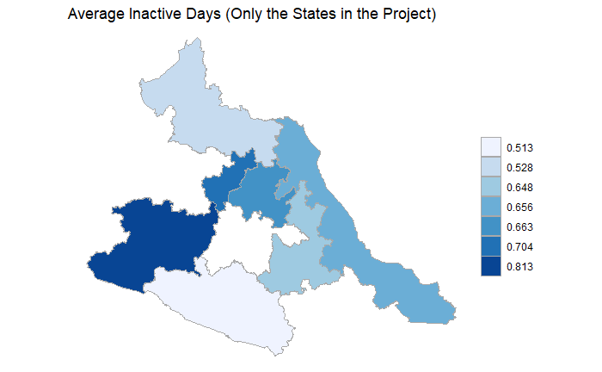

Graph 5

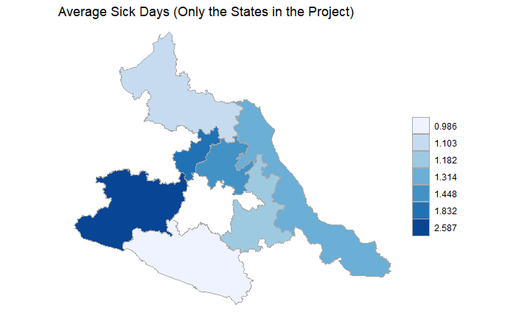

Graph 6

One interesting state by state analysis we found while playing with the numbers was that each state actually had a different result in living standards from the program. In the paper, there is a coefficient that is formed that summarizes the effect of the Oportunidades program on overall living standards. The numbers vary massively from state to state. For example, the state of Michoacan’s coefficient is a massive 83.304. This number is saying that there was a huge positive impact on living standards for that state. However, for the state of San Luis, there is actually a slightly negative coefficient of -0.503. This result tells us that the program actually had a negative effect on living standards in San Luis. And for the state of Guerrero, the number is actually 0. This number tells us that on average, the living standards in Guerrero really did not change much. This could be due to the fact that some states are more rural than others and it could be something the Oportunidades program could look into when deciding which states the program should be employed in.

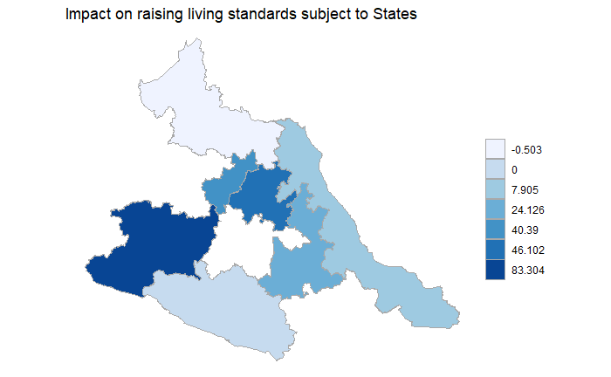

Graph 7

Impact of Household living condition

We also ran a new analysis to investigate the effect of home assets on long-term consumption effects. We removed three variables, availability of electricity at home, ownership of their home, and the use of the dirt floor, from the model to detect the effect by comparing the coefficients of the key variables. Based on the results, we find little difference in the coefficients of the key variables in the new model and the original one. This manipulation provides us intuition that CCT reception had similar long-term consumption effects for families of varying home asset ownership. 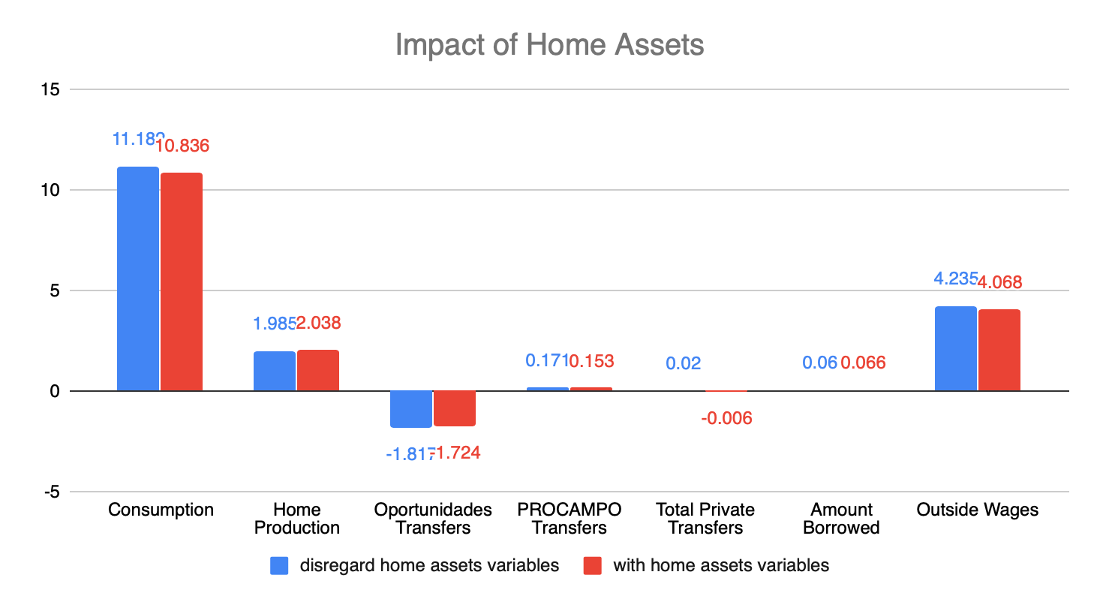

Graph 8

Social Impact

As Federal agencies in Mexico prioritize between competing for public programs and spending alternatives, Oportunidades or similar cash transfer should be prioritized over programs that lack evidence or show improvements to living standards only during the duration of a program’s activity. In allocating resources to public programs and deciding between Oportunidades and another program that also has implied increases in consumption beyond the end of the program, a return on investment comparison can inform spending choices using a conservative estimate of 0.016 for Oportunidades (an increase of 41.9 pesos per capita per month through the investment pathway, and 21.8 increase in consumption; or 5.6 percent higher consumption gains over 4 years).

In general, conditional cash transfer programs such as Mexico’s Oportunidades that provide cash investment works efficiently under the appropriate investment of the human capital of the next generation. ‘Cash transfers appear to increase living standards permanently by facilitating investments in productive activities.’ Therefore, there should exist policy enforcing the use of the cash transfer to guarantee it is invested in the next generation.

Another conclusion is that the beneficiary households will not revert to the poverty level after the removal of the cash transfer program. Also, a minimum of 9 years of program benefits is likely to have a large and significant effect. Therefore, government agencies or the education department that is considering this similar program for raising the poverty family’s living standard should consider a length of around 9 years of continuous operation in the program.

The Oportunidades program, from the research, seems to be correlated with raising household’s productivity, poverty, living conditions, and much more. More importantly, the program seems to have a sustainable, long-term effect as well. Also, the program has a minimum of 9-year support for families who enter the program. All of this points to a positive trend and there should be more funding for programs such as the Oportunidades program, or other cash transfer programs that can be sustained for years to come.

Epilogue

Since then the program was rebranded as PROGRESA and remains a positive example of evidence-based government intervention at the acclaimed level of Bolsa in Brazil, and as far as research, we realized last night that the age-stratified effects might be something the authors themselves noticed at some point, though they didn’t mention it in the paper, because subsequent articles by Gertler and other authors have centered around child-specific effects including impact of CCTs on child health.

Reference

Investing Cash Transfers to Raise Long-Term Living Standards. Gertler, Paul J., Sebastian W. Martinez, and Marta Rubio-Codina. 2012. American Economic Journal: Applied Economics,4(1): 164–92.

Article Link: <https://www.aeaweb.org/articles?id=10.1257/app.4.1.164>

Gertler, P., Martinez, S., and Rubio-Codina, M.(2012). Investing Cash Transfers to Raise Long-Term Living Standards. American Economic Journal: Applied Economics,4(1): 164–92.

Sadoulet, Elisabeth, Alain de Janvry, and Benjamin Davis. (2001). “Cash Transfer Programs with Income Multipliers: PROCAMPO in Mexico.” World development, 29(6): 1043–56.

Woodruff, Christopher, and Rene Zenteno. (2007). “Migration Networks and Microenterprises in Mex- ico.” Journal of development Economics, 82(2): 509–28.

Yang, D. (2008). “International Migration, Remittances and Household Investment: Evidence from Philippine Migrants’ Exchange Rate Shocks.” Economic Journal, 118(528): 591–630

Article Link: https://www.developmentpathways.co.uk/blog/the-demise-of-mexicos-prospera-programme-a-tragedy-foretold/

[1]

1. Other stakeholders that are not as invested in the research but still have incentives are The Mexican Agricultural Department, the Department of Education, Mexico’s Healthcare System, and other poverty-stricken countries. The 3 departments of Mexico that we mentioned all have incentives to know whether or not the Oportunidades program positively affects Mexico. The main idea of the cash transfer is for families to invest their money from the program into agriculture and create agricultural products. The Agricultural Department would be interested to see the program’s effectiveness on the country’s agriculture as a whole. There is a long-term health analysis in the research as well. The Healthcare system would love to see results that show the Oportunidades Program correlates with fewer sick days. The Oportunidades program also pays more to families whose children attend school often and receive passing marks on exams. The Department of Education would love to see more students come to school and achieve high scores.